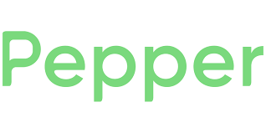
March 16, 2026

Dear Valued Supplier,

Pepper is an ecommerce solution that serves 500+ food distributors to power their ecommerce through custom white-label apps. Additionally, 100,000+ active users leverage our distributors’ apps to shop, place orders, and discover new items through Pepper ads.

To ensure products are represented correctly and consistently, we are seeking to receive your product information, specifically images and nutritional data. We are partnering with 1WorldSync by Syndigo to receive product information from manufacturers via the GDSN.

To get started, visit the https://syndigo.com/pepper/ and complete the trading partner form.

Following that, immediately begin publishing your GDSN product information to the Pepper’s GLN# 0860010615713.

Let’s work together to enhance your brand’s visibility and drive sales across our extensive network of foodservice professionals.

If you have any questions, please contact the 1WorldSync by Syndigo technical support team at technicalsupport@1worldsync.com or call 1-866-280-4013. Or you can contact Anders Peterson at Pepper directly at mailto:salt@usepepper.com.

